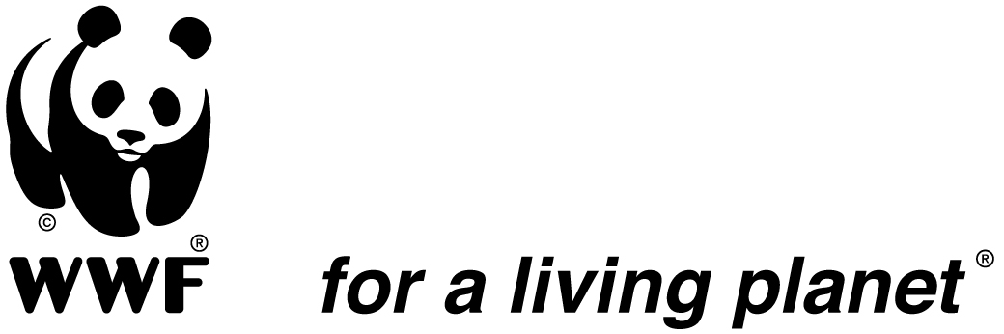

Job announcement

‘’Communications, Fundraising and Partnership Manager’’

Want to make a positive difference to the future of people and our one shared home, the Earth? Working at WWF could be your opportunity of a lifetime.
All around the world, people are waking up to the deepening crisis of nature loss. A growing realization that nature is our life-support system. And that nobody will be spared from the impacts of its loss. Here at WWF, we are helping to tackle this enormous global challenge.
Our people come from hugely diverse backgrounds and with a variety of expertise, ranging from HR and finance to advocacy and conservation science. We welcome applications from anyone who believes they can help us create a better future for people and wildlife.
What we do
We are an independent conservation organization, striving to sustain the natural world for the benefit of people and wildlife. From individuals and communities to business and government, we are part of a growing coalition calling on world leaders to set nature on the path to recovery by 2030. Together, we seek to protect and restore natural habitats, stop the mass extinction of wildlife, and make the way we produce and consume sustainable.
In that context, we are looking for a dynamic and committed Communications, Fundraising and Partnership Manager to support conservation efforts and ensure WWF DRC’s conservation targets are met through strategic promotion of WWF DRC Brand among different audiences and supporting the fundraising effort in the country and within the Network in line with the WWF – DRC Strategic Plan and Communication Strategy.

Office base: Kinshasa, Democratic Republic of Congo

Duration of contract: one years with renewal possibility

Main responsibilities:
- Develop, implement and periodically revise a Communication, Fundraising and partnerships strategy for WWF DRC.
- Work in close collaboration with WWF DRC Country Management Team (CMT) to develop and implement effective internal and external public relations & communication strategies for communicating WWF DRC conservation initiatives and enhancing corporate image, visibility and brand;
- Ensure the establishment of cross-functional fundraising and partnership network for WWF DRC and provide support, guidance to program managers in fundraising and partnership matters.
- Coordinate the drafting of project proposals to donors.
- Ensure effective implementation of WWF DRC proposals and contract management systems and adherence of relevant staff to WWF network Standards and best practices for engaging public and private finance partners and private donors.
- Contribute to solutions ensuring that field programs comply with donor agreements, timely technical and financial reporting to donors;
- Contribute to identify and oversee management of major reputational risks for WWF related to the execution of grant and partnership contracts;
- Contribute to the design and implementation of innovative and sustainable funding mechanisms for DRC conservation;
- Develop and manage WWF DRC Partnerships agreements, as needed.
- Assists programmes in developing and improving their communication abilities and products. As such conducts communication trainings, drafts and/or reviews programme materials for various audiences and platforms;
- Ensures effective management of WWF DRC websites and social media, and ensures relevant and up to date content;
- Respond to local and international media queries; as needed, organize media visits to WWF DRC key sites;
- Liaise with other WWF communicators in Africa for joint campaigns;
- Provide leadership and directly supervise the DRC communication officer and the Fundraising & Partnership Manager;
- Coordinate setting of both departmental work plans and staff performance targets and undertake periodic performance appraisal for communication and Fundraising staff.

What you need:
Required Qualifications
- Advanced university degree in business management, international relations, Communications, Development Studies or related fields;
- Proven track record in communication and fundraisings, at least 7 years’ professional experience in inter-institutional relationship management, program development and fundraising;
- Proven knowledge and experience of the not-for-profit sector, preferably in the environment sector;
Required Skills and Competencies
- Understanding of institutional and legal framework in DRC as it relates to media and communication issues;
- A good understanding of DRC/Central African media landscape;
- Visionary leadership in organisational branding;
- Knowledge and experience of the realities of conservation & development issues, donor strategies, funding instruments and contract administration.
- Excellent inter-personal skills, and proven ability to build and maintain strong relationships,
- Strong cross-cultural skills and flexibility in dealing with different types of partnerships;
- Strong partnership-building and event planning skills
- Thorough understanding of all components of a diversified funding base
- Ability to develop and manage budgets and prepare financial reports
- Personal integrity with an honest and open personal style;
- Excellent oral and written communications skills in English and French;
- Ability to engage partners at all levels;
- Adherence to WWF’s behaviours, which are: Strive for impact, listen deeply, collaborate openly and innovate fearlessly.
- Adherence to WWF’s values, which are: Courage, Integrity, Respect and Collaboration.

How to apply?
Interested candidates should email a cover letter (with at least 3 references) and curriculum vitae to: recruit-wwfdrc@wwfdrc.org , with the mention: - Comms, F&P Manager by October, 10 2021.
Thank you in advance for your interest in this position. Please note that only candidates under serious consideration will be contacted for follow up. If you have not been contacted six (6) weeks after closing, consider your application unsuccessful.
Female applicants are encouraged. WWF is an equal opportunity employer and committed to having a diverse workforce

