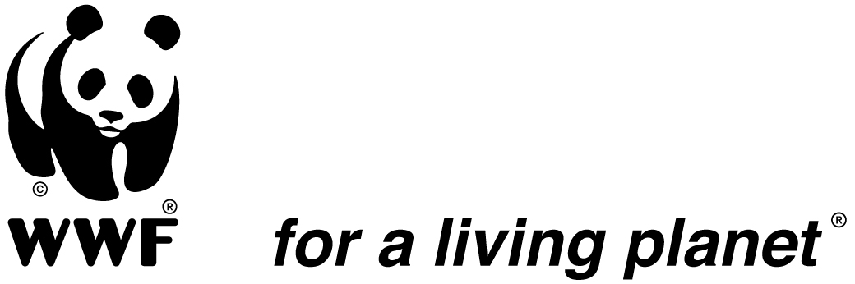

JOB DESCRIPTION

Position Title: Communications, Fundraising and Partnership Manager
Reports to: Country Director of DRC WWF
Supervises Communication and Fundraising & Partnership Officers
Post base: Kinshasa
Date: August 2021

- Mission of the Department

To support conservation efforts and ensure WWF DRC’s conservation targets are met through strategic promotion of WWF DRC Brand among different audiences and supporting the fundraising effort in the country and within the Network in line with the WWF – DRC Strategic Plan and Communication Strategy.

- Major Functions
- Ensure that WWF DRC produces and promotes high quality strategic communication on its conservation programmes, in line with and of relevance for its Strategic Plan, WWF Regional Office for Africa Communication & Branding Strategy and WWF International Overall Communication Strategy;
- Ensure that effective and strategic communication strongly supports resource mobilization from diverse partners.
- Ensure that WWF DRC maintains positive and effective partnerships and purposeful relationships relevant to the implementation of WWF DRC Strategic Plan.
- Ensure the visibility of the organization in the public space, including but not limited to the internet and social media.
- Major Duties and Responsibilities
- Develop, implement and periodically revise a Communication, Fundraising and partnerships strategy for WWF DRC.
- Work in close collaboration with WWF DRC Country Management Team (CMT) to develop and implement effective internal and external public relations & communication strategies for communicating WWF DRC conservation initiatives and enhancing corporate image, visibility and brand;
- Ensure the establishment of cross-functional fundraising and partnership network for WWF DRC and provide support, guidance to program managers in fundraising and partnership matters.
- Coordinate the drafting of project proposals to donors.
- Ensure effective implementation of WWF DRC proposals and contract management systems and adherence of relevant staff to WWF network Standards and best practices for engaging public and private finance partners and private donors.
- Contribute to solutions ensuring that field programs comply with donor agreements, timely technical and financial reporting to donors;
- Contribute to identify and oversee management of major reputational risks for WWF related to the execution of grant and partnership contracts;
- Contribute to the design and implementation of innovative and sustainable funding mechanisms for DRC conservation;
- Develop and manage WWF DRC Partnerships agreements, as needed.
- Assists programmes in developing and improving their communication abilities and products. As such conducts communication trainings, drafts and/or reviews
programme materials for various audiences and platforms;
- Ensures effective management of WWF DRC websites and social media, and ensures relevant and up to date content;
- Respond to local and international media queries; as needed, organize media visits to WWF DRC key sites;
- Liaise with other WWF communicators in Africa for joint campaigns;
- Provide leadership and directly supervise the DRC communication officer and the Fundraising & Partnership Manager;
- Coordinate setting of both departmental work plans and staff performance targets and undertake periodic performance appraisal for communication and Fundraising staff.

- Profile

Required Qualifications
- Advanced university degree in business management, international relations, Communications, Development Studies or related fields;
- Proven track record in communication and fundraisings, at least 7 years’ professional experience in inter-institutional relationship management, program development and fundraising;
- Proven knowledge and experience of the not-for-profit sector, preferably in the environment sector;
Required Skills and Competencies

- Understanding of institutional and legal framework in DRC as it relates to media and communication issues;
- A good understanding of DRC/Central African media landscape;
- Visionary leadership in organisational branding;
- Knowledge and experience of the realities of conservation & development issues, donor strategies, funding instruments and contract administration.
- Excellent inter-personal skills, and proven ability to build and maintain strong relationships,
- Strong cross-cultural skills and flexibility in dealing with different types of partnerships;
- Strong partnership-building and event planning skills
- Thorough understanding of all components of a diversified funding base
- Ability to develop and manage budgets and prepare financial reports
- Personal integrity with an honest and open personal style;
- Excellent oral and written communications skills in English and French;
- Ability to engage partners at all levels;
- Adherence to WWF’s behaviours, which are: Strive for impact, listen deeply, collaborate openly and innovate fearlessly.
- Adherence to WWF’s values, which are: Courage, Integrity, Respect and Collaboration.

- Working Relationships

Internal: Interact and work closely and on a regular basis with finance and administrative staff in all WWF DRC offices. Coordinate and interact as appropriate with members of WWF Africa, WWF International, and other WWF offices.

External: Interacts as required with donors and other stakeholders, as required by the Country Director as appropriate.

This job description covers the main tasks and conveys the spirit of the sort of tasks that are anticipated proactively from staff. Other tasks may be assigned as necessary according to organizational needs.

Prepared by: _______________________________ Date: ___________________

Reviewed by: ______________________________ Date: ___________________

Approved by :______________________________ Date:__________________

Accepted by: ______________________________ Date: __________________

